# Software Requirements Specification

# for

# Physor

# (E-learning Website)

Version 1.0

Prepared by

Soumya Ranjan Bhoi

Tejasmaya Sitha

Harshvardhan Naik

Rajendra College (Auto), Balangir

Computer Science Department

16-03-2022

Table of Contents

Table of Contents ii

Revision History ii

1. Introduction 1

1.1 Purpose 1

1.2 Document Conventions 1

1.3 Intended Audience and Reading Suggestions 1

1.4 Product Scope 1

1.5 References 1

2. Overall Description 2

2.1 Product Perspective 2

2.2 Product Functions 2

2.3 User Classes and Characteristics 2

2.4 Operating Environment 2

2.5 Design and Implementation Constraints 2

2.6 User Documentation 2

2.7 Assumptions and Dependencies 3

3. External Interface Requirements 3

3.1 User Interfaces 3

3.2 Hardware Interfaces 3

3.3 Software Interfaces 3

3.4 Communications Interfaces 3

4. System Features 4

4.1 System Feature 1 4

4.2 System Feature 2 (and so on) 4

5. Other Non-functional Requirements 4

5.1 Performance Requirements 4

5.2 Safety Requirements 5

5.3 Security Requirements 5

5.4 Software Quality Attributes 5

5.5 Business Rules 5

Revision History

|  |  |  |  |
| --- | --- | --- | --- |
| **Name** | **Date** | **Reason For Changes** | **Version** |
|  |  |  |  |
|  |  |  |  |

# Introduction

## Purpose

The Purpose or Objective of this web application **Physor** is to develop a thoughtful and analytical mindset of the students by reading, learning, practicing, and Sharing of Knowledge & Ideas among Students.

This Web Application Software is designed to help seekers learn concepts of Physical science and understand the laws of nature with a well perception.

This application will provide a well interface & contents that will help the user to develop a well understanding about notion of their interests in Science & Physics. This will help students to interact with their Physical world they perceive .and provide an easy way to get information about any specific concern. It can become a plentiful source of ideas and knowledge.

## Document Conventions

*This document follows the Turabian Citations. It contains Italicized text and Bold faces to emphasize the important words or highlighting sub-sections headings. Highlighted words or contents contains important meanings and information having higher priorities than other non-highlighted words.*

*Mostly every requirement has its own priority level and eliciting their need in the project, defined in this document.*

## Intended Audience and Reading Suggestions

In our project application, the intended audience and the users are mostly students of any departments or age who seek to know about the physical phenomenon happening around them or any person interested in learning about physical science.

We are the document writers, Shri Tejasmaya Sitha, Shri Soumya Ranjan Bhoi, Shri Harshvardhan Naik, students of Computer Science Department, Rajendra (Auto) College Balangir. We are also the developers, project managers, of this project. Testers will be the faculty of our department.

## Project Scope

The scope of this project is to build a learning environment for the user to acquire scientific knowledge and practice the subjects to get well acquainted about their skills in them. The software would store the information about the user interests to build better version of this software in further time. It also would store the login information about the user so that no outsider can access the software to make this software more secure.

Current trends and events would be displayed on the website accordingly. The trends section will be helpful to students to get current updates.

## References

### [IEEE Standard Glossary of Software Engineering Terminology](https://ieeexplore.ieee.org/document/159342)

[*https://ieeexplore.ieee.org*](https://ieeexplore.ieee.org/document/159342)

[*https://www.semanticscholar.org*](https://www.semanticscholar.org/paper/Standard-Glossary-of-Software-Engineering/dce99209120ebed7f5d68e3644fdcd160d4c366c)

### [ReqView Software Requirements Specification](https://www.reqview.com/papers/ReqView-Example_Software_Requirements_Specification_SRS_Document.pdf)

[*https://www.reqview.com*](https://www.reqview.com/papers/ReqView-Example_Software_Requirements_Specification_SRS_Document.pdf)

### [SOFTWARE REQUIREMENTS SPECIFICATION](https://agricoop.nic.in/sites/default/files/PGSsrs1_29022012.pdf)

[*https://agricoop.nic.in*](https://agricoop.nic.in/sites/default/files/PGSsrs1_29022012.pdf)

# Overall Description

This product provides facilities to the user to learn, practice and query questions about the topic or subject s/he intends. Using this software should make the learning process easier. User can develop his/her skill through practicing question available here. User can have a great experience using this product.

## Product Perspective

**PHYSOR** is a new and self-contained product. This is a web-based application made for students and seekers to help them in their learning, making it easier to understand concepts.

This would help user to save time and effort.

## Product Functions and Features

The software would provide the facility of viewing information to acquire knowledge based on posted articles, books, notes, or user views.

**Functions Summary: -**

* Interactive user Interface
* Logo
* Home page design
* User Sign up and login
* User menu
* Topic tabs
* Create and store user data in Database
* Search bar
* Navigation bar
* Website guide
* Recent / Latest
* Featured
* Newsletter form
* External links for different outside tutorials
* Query section
* Feedback section
* Documents Section
* Blogs
* Responsiveness
* Comments on articles
* Multi Account management
* Data is secure
* Cloud Storage for different articles
* Tutorials
* Subject categories in Menu
* Question answer section
* Notifications section
* Profile Management Section
* Social Media links of the developers
* Tabs and options
* Notifications
* Back to top

## User Classes and Characteristics

The major user classes of this product are as follows: -

**1)Developers:**

Developers design the product and add the functionalities to it. They understand the requirements and design the application which meet those requirements.

**2)Administrators:**

Admins have the supreme power of the application. Admin is responsible for maintaining and updating the whole system. Admin has the responsibility to give current

notifications.

**3)End users:**

End users are the ones for whom the application is intended for. Users need to sign up/login with their Unique ID and password to access the software. Users can filter topics based on their requirements and interests. They use the product as it is designed by the developers but can’t change or intervene it.

## Operating Environment

Any computer system with internet connectivity is suitable to run this application. We can run our product on every OS platform as it is a web-based application and only require a suitable browser application which supports HTML5.

## Design and Implementation Constraints

A Domain server would be an issue for the developers as this product is initially a standalone program. To make the product available to users and to upload the application data to a web database a cloud Domain is mandatory.

User should have installed a suitable browser. viz. (Google Chrome, Mozilla Firefox, Opera, Brave, UC browser, Lynx, Safari, ...etc.). Running the application would necessarily require this.

## User Documentation

Following online helps are used on designing this web application

* <https://iflscience.com/>
* <https://dev.to/t/devtips>
* <https://lumenlearning.com/>
* <https://www.britannica.com/>
* <https://www.academia.edu/>
* <https://projecttunnel.com/>

## Assumptions and Dependencies

*It is assumed that the users have devices with web browser installed and a connection of internet to access our web application.*

*Speed of the usability of the website entirely depends upon the Network the user is using.*

# External Interface Requirements

## User Interfaces

* **Landing page:**

When a user visits our web site, the landing page visible will be like the figure (3.i) given: -

Header contains the links which connect the user to the respective web page. It contains the information regarding the Home, About, Topic and Profile section. The user has to login to their profile to save and view their progress and tutorials.

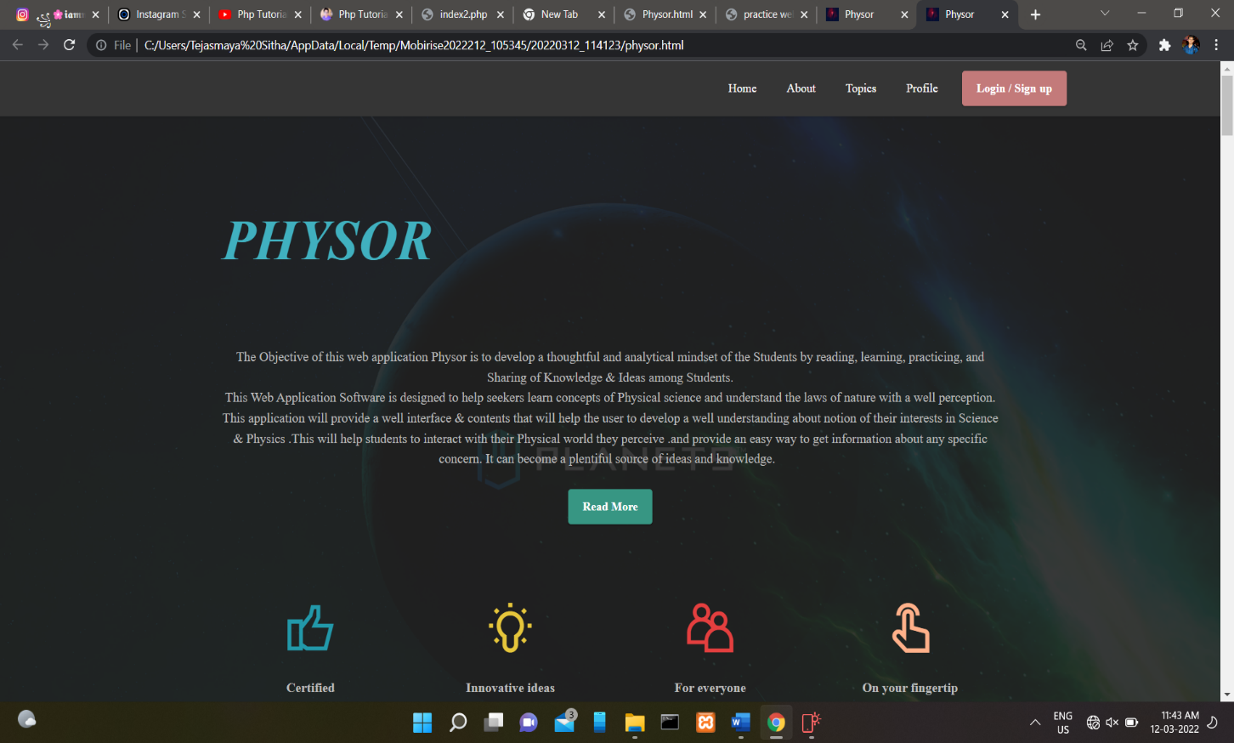

The landing page contains the name of the web application i.e., PHYSOR and the purpose of the web application.

* **Home page:**

After the login page user is directed to home page. Here User can see different tutorial that are provided by the application.

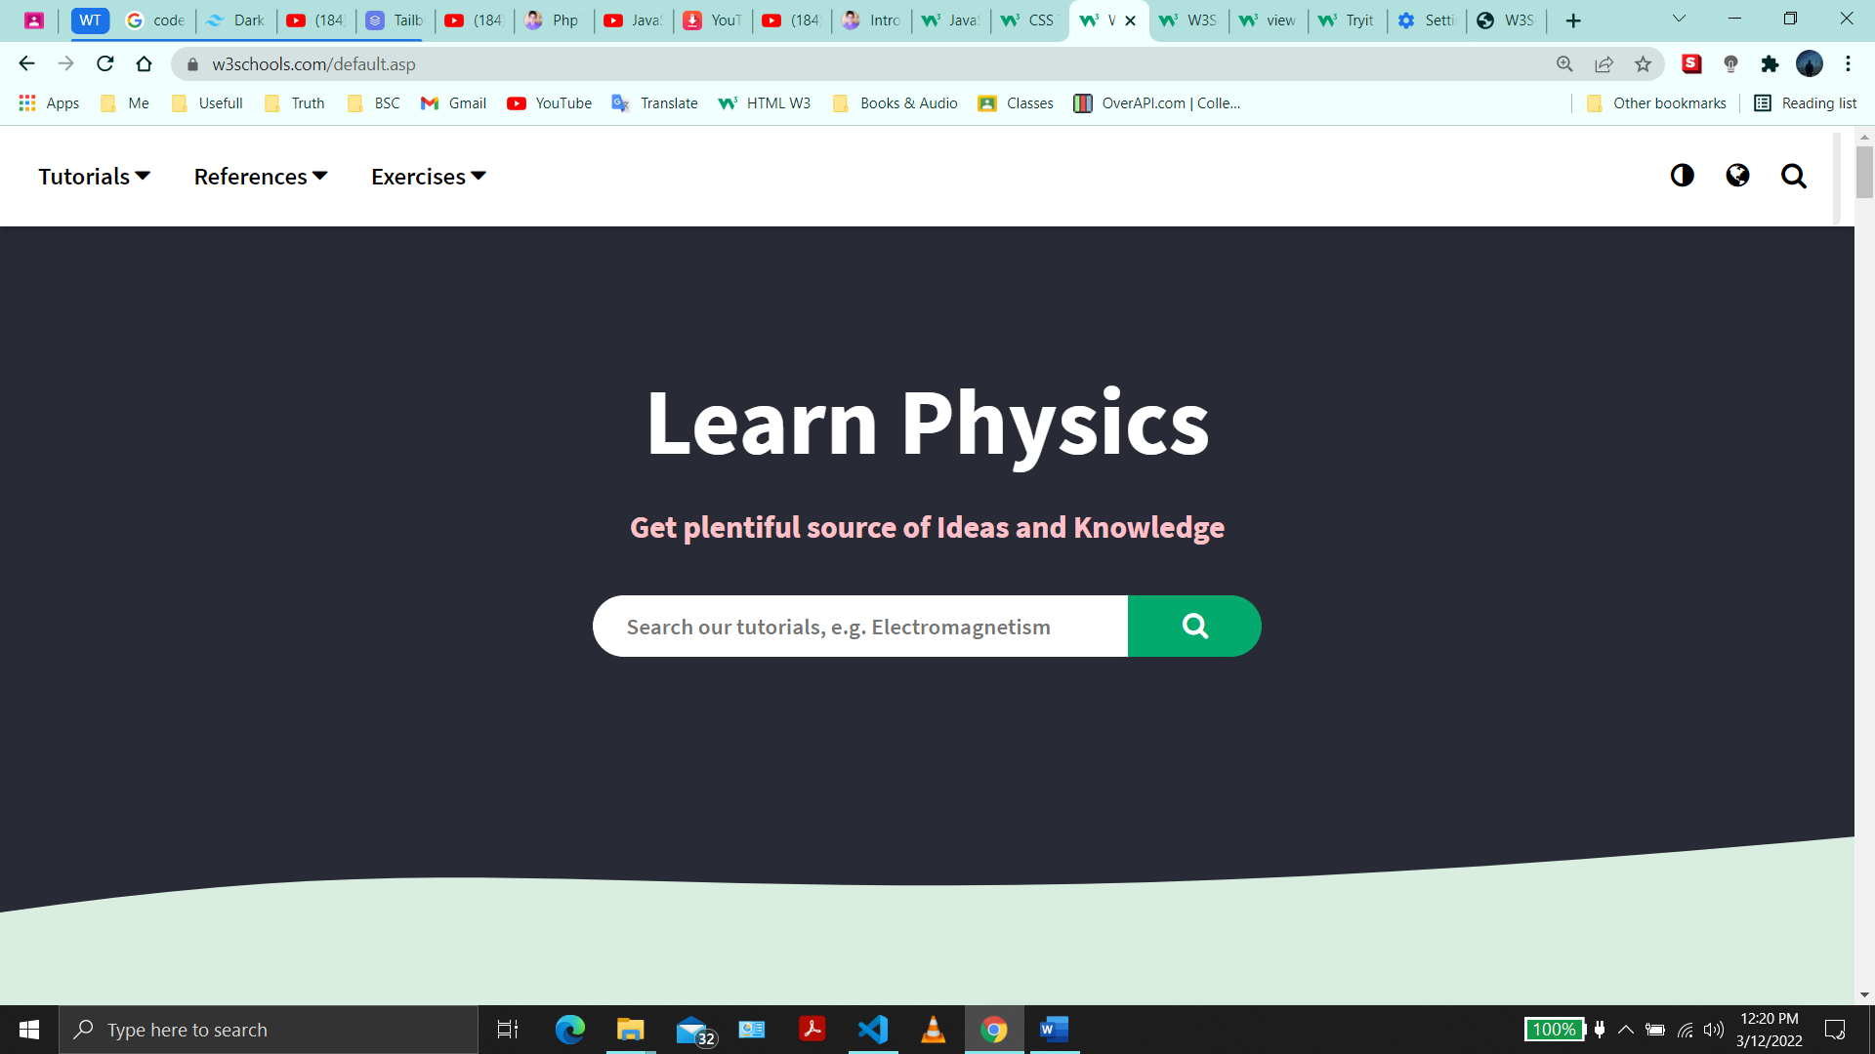

User can search and learn Physics topics in the search bar provided above. Different references are provided to expand our courses offered, and the user can learn from different sources other than ours only.

* **Profile:**

Profile section contains the user information like username, Email address, login information, their expertise level, their progress in the specific course they have opted to learn.

Profile info class is used to represent information about a user profile from the data store, including the last date and time when profile properties were retrieved or updated, the username associated with the profile, and whether the profile is for an anonymous or authenticated user.

* **About:**

After clicking the about button in the landing page user is directed to the about section of PHYSOR. It contains the rights owned by PHYSOR, privacy policy terms & conditions and the third-party notices.

This section contains the contact details (E-mail) of the developers for interaction between users and developers.



* **Log-in/Signup:**

Login forms are one of the most important user interface elements.

*Unlike other types of user interface forms, login forms do not come in all shapes and sizes. They are limited to the number of fields that are used. The reason for such a minimal and capsule approach is trivial: people do not like to fill in forms. Developer cannot be asking for too much personal information. These forms should be simple, familiar, and straight to the point.*

*As a rule, the login form includes two inputs, links to alternative scenarios, and a submit button. Even though you must be concise, still there is plenty to choose from:*

* *Username field*
* *Email field*
* *Telephone number field*
* *Password field*
* *Alternative login options (Facebook, Twitter, Amazon, Adobe, Apple, etc.)*
* *Forgot password link*
* *Submit button*
* *Show password option*
* *Keep me logged in option*
* *Registration link*

*As a rule, developers prefer to use these fields: ­*

* *Email field*
* *Password field*
* *Alternative login options*
* *Forgot password link*
* *Submit button*

*Depending on the purpose of your login form, you may choose one or another field or extend this default pack with other options.*

## Hardware Interfaces

Physor will communicate with the filesystem and the database on the server end via appropriate program code. The user can communicate through browser using keyboard and display with the help of GUI.

Supported devices:

Desktop, PCs, Smart Phones, Tablets…

The browser should be based on Chromium 95 or above.

## Software Interfaces

Following are the software used for the flight management online application. These *Include the software details as per our project:*

|  |  |
| --- | --- |
| **Software used** | **Description** |
| Operating system | We have chosen Windows operating system for its best support and user-friendliness. |
| Database | To save the user records, courses record we have chosen SQL+ database. |
| Editor | We have used Visual Studio Code because it provides different snippets and the emmet abbreviation. |
| Programming Language Interfaces | Hyper Text Mark-up Language version 5  Cascaded Style Sheet version 3  JavaScript |
| Database Connections | Hypertext Pre-Processor  XAMPP |

## Communications Interfaces

PHYSOR shall use the HTTP protocol for communicating over any network (mainly in LAN).

User can access the web application through a web browser in their system that relates to internet.

Email is mandatory for login purposes as the user must login into their profile to access the application.

HTTP protocol is used as the primary protocol to transfer request, queries, and response from the server.

FTP is used to transfer files between server database and user.

General bandwidth should be maintained for data transfer and synchronization between databases and provide consistencies.

The below-listed points describe working with the web application process:

* Initially, the client will request to HTTP server through HTTP.
* Next, the web server will send a message to the static data store with the help of static data request.
* The web server responds to a static data store and moves to an application server by using the servlet request that includes web container and other services.
* Then servlet request extracts information from the application data store and responds to a web server.
* In the end, the webserver gives a response to the user by using HTTP Response.

# System Features

**4.1. Functional Requirements:**

*1.Registration:*

*The user should be registered to the website.*

*2.Login:*

*The registered user can login to the website through username and password.*

*3.Navigation bar:*

*Navigation bar contains the different sections (Home, About, Topics etc.)*

*4.Home:*

*On clicking the Home button, user will be directed to the Home page.*

*On the navigation section of home page different tabs will be present like Tutorials, References, Exercises etc.*

*I. Tutorials*

*Tutorials section would contain different blogs, posts, documents or links according to the selected topic.*

*II. References*

*This section would contain various articles, books and web references on the particular topic.*

*III. Exercises*

*This section would contain different questions and exercises regarding the subject for practice purpose*

*IV. Search bar*

*Search bar would be very useful for searching any topic user want to learn. The given query will be searched inside the database linked to the website.*

*5.About:*

After clicking the about button in the landing page user is directed to the About section of PHYSOR. It contains the rights owned by PHYSOR, privacy policy terms & conditions and the third-party notices.

This section contains the contact details (E-mail) of the developers for interaction between users and developers.

*6.Topic Tabs:*

*Topic tab would be scroll down button containing different topics to be*

*selected.*

*Selected topic will be saved to provide tutorials and articles related to the selected topic.*

*7.Menu:*

*Menu tab helps the user to choose and select their intended course and topic to learn.*

**i) Sign up/Login:**

|  |  |
| --- | --- |
| Use Case name | Sign up/Login |
| Actor | User |
| Brief Description | This use case allows the user log onto the PHYSOR Website and access the materials provided. |
| Goals | To login to the system or website. |
| Triggers | User access the PHYSOR Website. |
| Pre-Condition | User should be in the homepage that requires username and password to login. |
| Post-Condition | User can select topics and access the courses. |
| Basic Flow | User gives the details and click on the login button for login to System. |
| Alternative Flow | User can also access the features of Physor as a guest without logging in. |
| Exception | Login will be abandoned on providing wrong details. |

**ii) Profile management:**

|  |  |
| --- | --- |
| Use Case name | Profile management |
| Actor | User |
| Brief Description | This allows the user to manage their profile like changing name, updating phone number etc. |
| Goals | To make user to manage their profile. |
| Triggers | User have to click the Profile button provided in the Menu section. |
| Pre-Condition | The user must be logged into the account. |
| Post-Condition | After modification their profile will be updated. |
| Basic Flow | User opens the PHYSOR website.  User logs into their account.  User clicks on Profile button provided in the Menu section.  User Can modify their profile. |
| Alternative Flow | None |
| Exception | User can rollback at any instance. |

**iii) User menu:**

|  |  |
| --- | --- |
| Use case name | View user menu |
| Actor | User |
| Brief Description | This allows the user to view the Profile, Tutorials etc. |
| Goals | Providing accessibility for profile management and content selection. |
| Triggers | User have to click the menu button in the home page |
| Pre-Condition | User need to be in the Home page of Physor either logged in or not |
| Post-Condition | User can manage their profile, and select contents. |
| Basic Flow | User have to visit our PHYSOR website  User can login to their account  Visit the home page  Click the Menu button in home page |
| Alternative Flow | Visit the home page  Select the Menu button |
| Exception | User can rollback at any instance. |

**iv) Search:**

|  |  |
| --- | --- |
| Use Case name | Search |
| Actor | User |
| Brief Description | This allows the user to search any content on the website. |
| Goals | To search the query in the PHYSOR database |
| Triggers | User has to click on the search bar |
| Pre-Condition | User has to input any query for search. |
| Post-Condition | User can view the search results. |
| Basic Flow | User have to visit our PHYSOR website  User can login to their account  Visit the home page  User searches the query. |
| Alternative Flow | None |
| Exception | Error will be displayed if the searched item is not found in the database. |

**v) Select Topic:**

|  |  |
| --- | --- |
| Use case name | Select Topic |
| Actor | User |
| Brief Description | This is a scroll down button to select among provided topics. |
| Goals | Enabling users to select any topic. |
| Triggers | User have to click the topic button in the home page |
| Pre-Condition | User need to be in the Home page of Physor either logged in or not |
| Post-Condition | User can select any given topics. |
| Basic Flow | User have to visit our PHYSOR website  User can login to their account  Visit the home page  Click the Topic button in home page |
| Alternative Flow | Visit the home page  Select the Topic button |
| Exception | None |

**vi) Tutorials:**

|  |  |
| --- | --- |
| Use case name | Watch Tutorials |
| Actor | User |
| Brief Description | This is a list of available Tutorials. |
| Goals | Enabling users to select any Tutorial. |
| Triggers | User have to click the Tutorials button in the home page |
| Pre-Condition | User need to be in the Home page of Physor. |
| Post-Condition | User can select any given Tutorial. |
| Basic Flow | User have to visit our PHYSOR website  User needs to login to their account  User has to visit the home page  Click the Tutorials button in home page |
| Alternative Flow | None |
| Exception | None |

**vii) Read article:**

|  |  |
| --- | --- |
| Use case name | Read article |
| Actor | User |
| Brief Description | This is a list of available articles. |
| Goals | Enabling users to select any article. |
| Triggers | User have to click the Menu button in the home page |
| Pre-Condition | User need to be in the Home page of Physor. |
| Post-Condition | User can select any given article. |
| Basic Flow | User have to visit our PHYSOR website  User needs to login to their account  User has to visit the home page  Click the Menu button in home page  Choose any article |
| Alternative Flow | None |
| Exception | None |

**viii) References:**

|  |  |
| --- | --- |
| Use case name | See References and External links |
| Actor | User |
| Brief Description | This is a list of available links and external references. |
| Goals | Enabling users to select any link. |
| Triggers | User have to click the References button in the home page |
| Pre-Condition | User need to be in the Home page of Physor. |
| Post-Condition | User can select any given References. |
| Basic Flow | User have to visit our PHYSOR website  User needs to login to their account  User has to visit the home page  Click the References button in home page  Choose any References or Links |
| Alternative Flow | None |
| Exception | None |

**ix) Comment:**

|  |  |
| --- | --- |
| Use case name | Comment Section |
| Actor | User |
| Brief Description | This section enables the user to comment on any content. |
| Goals | User can comment on any article or tutorials. |
| Triggers | User have to click the text area given in the comment section. |
| Pre-Condition | User must be logged in. |
| Post-Condition | User can post comments. |
| Basic Flow | User have to visit our PHYSOR website  User needs to login to their account  User has to select any given article or Tutorial  User post comments |
| Alternative Flow | None |
| Exception | User may or may not post comments |

**x) Feedback:**

|  |  |
| --- | --- |
| Use case name | Feedback section |
| Actor | User |
| Brief Description | This is a text area for posting Feedback |
| Goals | Enabling users to post Feedback |
| Triggers | User have to click the text area on Feedback section |
| Pre-Condition | User need to be logged in |
| Post-Condition | User can post Feedback |
| Basic Flow | User have to visit our PHYSOR website  User needs to login to their account  User has to select given text area in Feedback section  User posts Feedback |
| Alternative Flow | None |
| Exception | User may not post Feedback |

**4.2. Use Case Diagram for Physor:**

*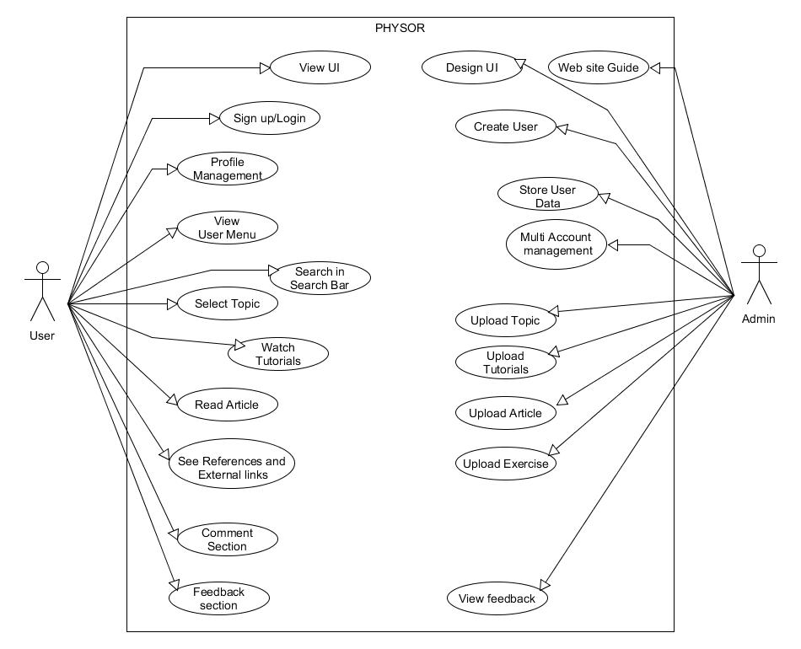***4.3. High level Design Diagram for Physor:**

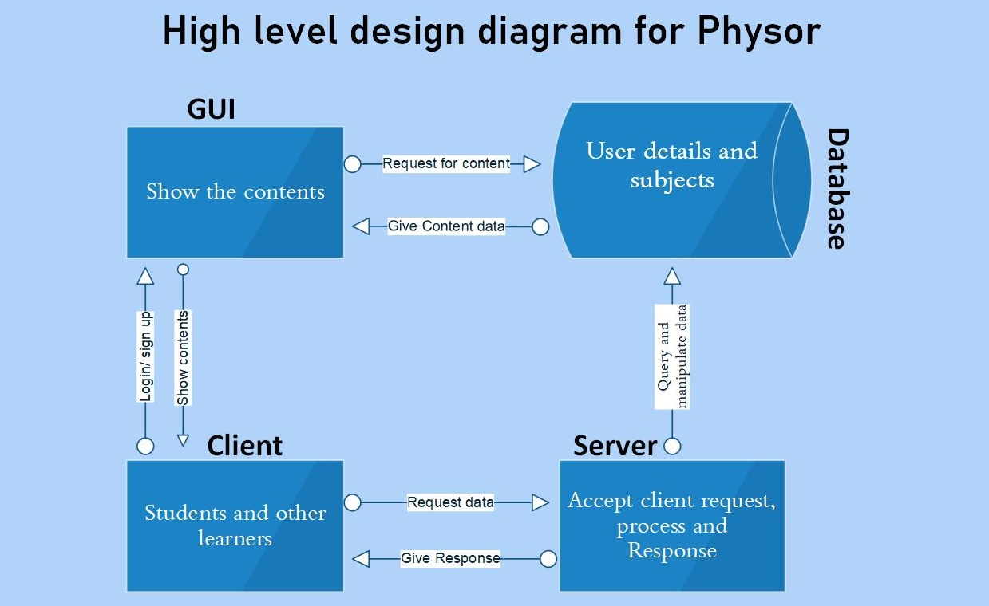

**4.4. Sequence Diagram for Physor:**

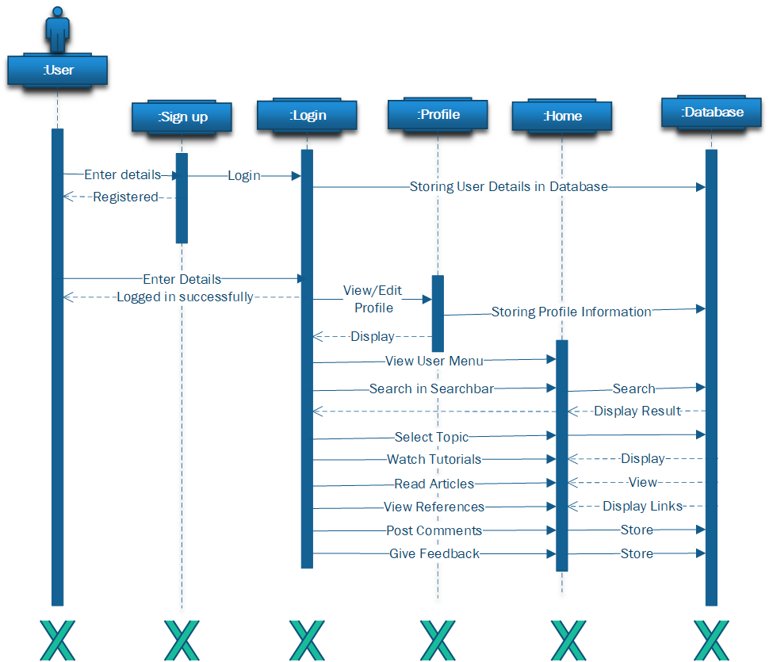 **4.4.1. Sequence Diagram for User:**

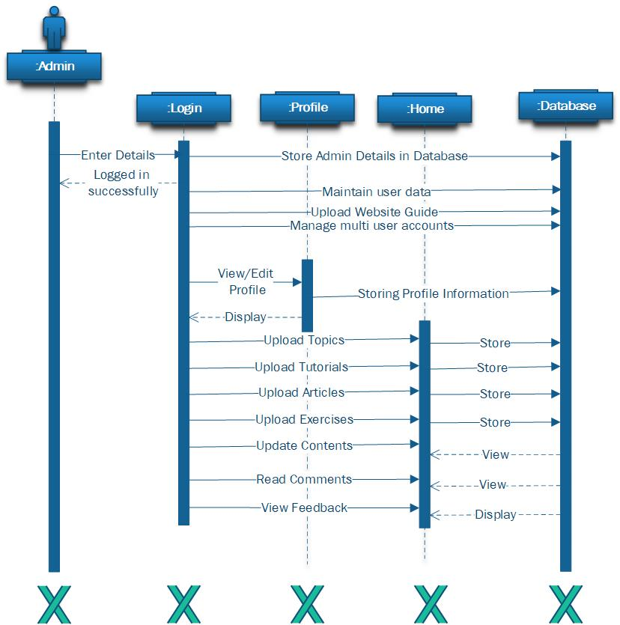 **4.4.2. Sequence Diagram for Admin:**

**4.5. Data flow Diagram:**

**4.5.1. Level 0 DFD:**

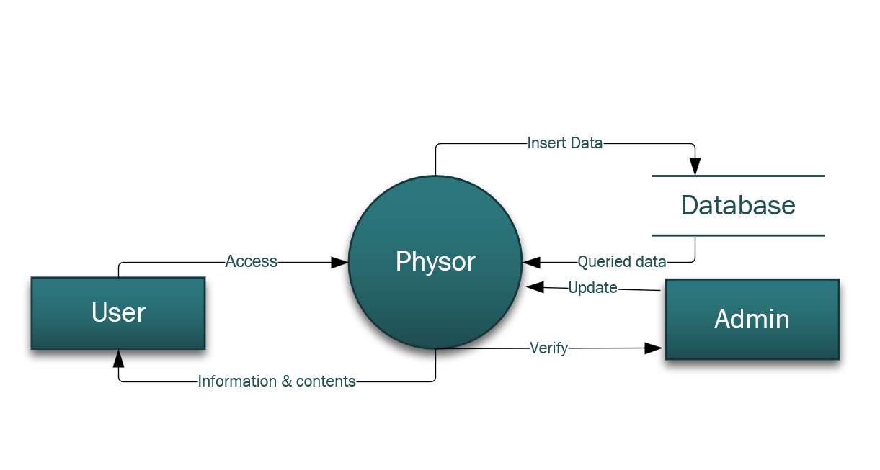

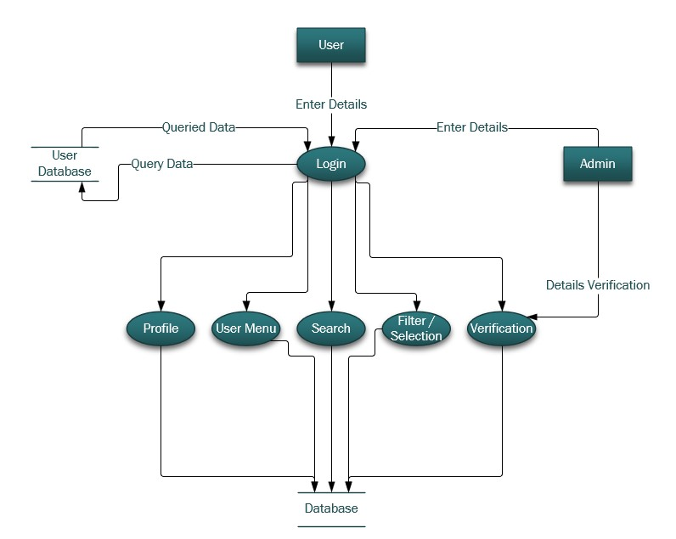 **4.5.2. Level 1 DFD:**

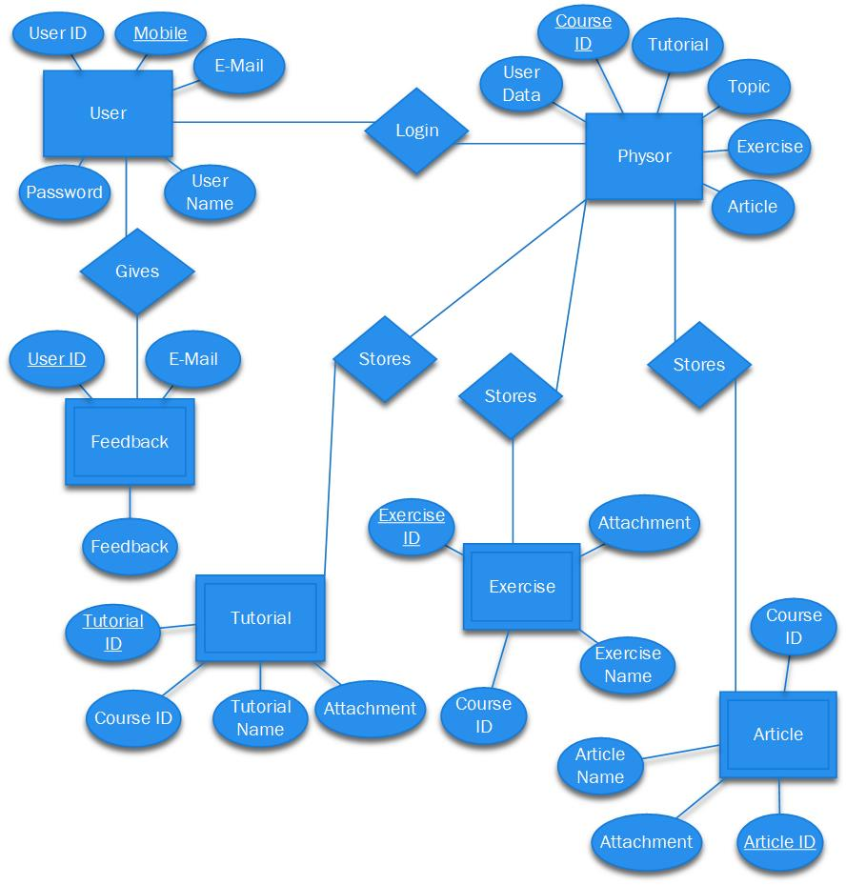**4.6. ER Diagram for Physor:**

# Other Nonfunctional Requirements

## Performance Requirements

The performance of the system mostly depends on the Network speed of the user gadget. It should be fast and accurate. It should be able to handle large amount of data. It should be able to handle large number of users.

The website should be Responsive as the user may open it from different devices other than Desktop.

## Safety Requirements

As this is a website there may be network issue or any technical issue or the site may get crashed. So back up and restore is a must have feature for this website.

Server may get jammed if there would be so many users simultaneously using the website. So, it would be required that a good server is chosen to handle such situation, and optimizing the performance of the server would reduce the chances of server slowing down or failure.

## Security Requirements

Sometimes due to different certifications requirement some browsers don’t allow websites without https:// in their URL (that are not secure). So, it would be necessary to get certified from the authorization.

The system uses Login/Signup process using unique ID and password so any unauthorized entry to the site or database is minimized. Also, database use the data abstraction method that helps to hide the hardware complexity of the database to the user.

## Software Quality Attributes

**Adaptability:**

As this is a website it is mostly adaptable to every system as it is independent of any Operating System or any Hardware Complexions. As the website runs on a web browser so any change to any field other than the web browser does not affect the website.

The website can be modified or changed according to need or requirement at any time easily which makes it adaptable to mostly all conditions.

**Availability:**

The website is available all over the world to any user using the www internet platform. A user can be anywhere in the world while accessing our website.

**Correctness:**

Correctness is easily checked as an internal quality factor. The website source contains accurate information, that can be verified by other external sources.

**Flexibility:**

The website is flexible in several natures provided by developers. It has the ability to flexibly adapt to future changes.

**Interoperability**:

It is the ability of the web server and the user (client) to communicate or exchange data easily and to use the data that has been exchanged.

**Maintainability**:

It is the ability of the website to be maintained easily and support changes cost-effectively. Physor is easily maintainable as it consists of small modules and functions.

**Portability**:

The website can run on numerous platforms such as data portability, hosting, viewing, etc., Physor is highly portable to any system or platform.

**Reliability**:

Physor will be so reliable as it will continue to operate over time.

**Reusability**:

Every function and module of Physor is reusable. With a little modification we can use it multiple time to build any new websites.

**Testability**:

It shows how well the website or component facilitates to perform tests to determine whether the predefined test criteria have been met.

**Usability**:

It is described as how the user is utilizing the website effectively and the ease of which users can learn to operate or control the system. Physor is so usable because of its simple user-friendly Interface.